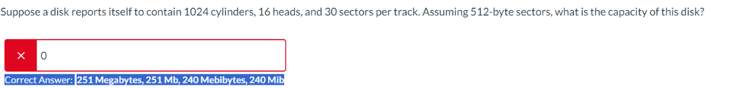

Capacity = 251,658,240 bytes

1 byte = 8 bits, so we need to convert bytes to bits:

Capacity = 251,658,240 bytes x 8 bits/byte = 2,013,265,920 bits

Capacity = 251,658,240 bytes ÷ (2^20 bytes/MiB) = 240 MiB (rounded to the nearest whole number).

Just ls is short

/ . refers to the root directory.

1991 –Linux started by Linus Torvalds, has built in kernel

1974 – Thompson and Ritchie publish landmark UNIX paper